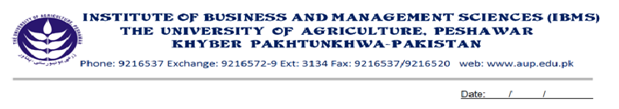
Programme: BS (IT)-V

Course Name: Introduction to Software Development
Course Code: IT- 501
Credit Hours: 03
Course Week: 16
Total Hours: 48

Course Objectives

At the end of the course, student will be able to understand the basic concepts of S/W engineering, life cycle of system design, and the complexity involved in it. The students will also be able to optimize the system, making it error free, and concentrate on quality using traditional S/W Engineering approaches.

Week 1
Introduction to System
Introduction to S/W Engineering

Week 2
S/W Process Models
-Linear Sequential
-Prototyping

Week 3
Incremental Model
Spiral Model

Week 4
System Engineering Hierarchy
System Modeling

Week 5
S/W Requirement
Functional & non Functional Requirements.
User Requirements
System Requirements

Week 6
S/W Prototyping
- Throw Away
- Evolutionary

Week 7
Elements of Analysis Modeling
Data Modeling
- Data Objects, Attributes, Relationships
- ERD
Week 8
Functional Modeling
- DFD
Behavioral Modeling

Week 9
The Data Dictionary.
S/W Design
The Design Principles

Week 10
Data Design.
Architectural Styles

Week 11
User Interface Rules
Interface Design Activities

Week 12
Component/Level
-Graphical Design Notation.
-Tabular Design Notation.
-Program Design Lang
Week 13

Software testing strategies:
- A Strategic Approach for Software Testing.
- Unit Testing.
Week 14
Integration testing.
-Top down
-Bottom up
-Regression
Week 15
-Validation Testing.
- Alpha/Beta Testing
-System Testing

Week 16
Quality Concepts
Quality Movements
S/W Quality Assurance.

Total Marks: 100

Recommended Books

- Software Engineering (Roger S. Pressman)
- Software Engineering (Ian Someruille)

